A new U.S. law could give the president the power to block digital asset trading. Asset management firm VanEck predicts that the price of Ethereum will reach $22,000 by 2030, driven by adoption by financial and large technology companies and the launch of spot Ethereum exchange-traded funds (ETFs). However, it may be some time before these ETFs are officially launched in the United States.
The Ethereum ecosystem has almost nine times as many daily active users as it did four years ago — and analysts say growing demand will push Ether to new heights.

According to data collected by crypto ETF issuer Bitwise, Ethereum and its scaling solutions Arbitrum and Polygon averaged more than 250,000 daily active users in the first quarter of 2020, with the lion’s share coming from the Ethereum Layer 1 mainnet.

By the first quarter of 2024, that number of daily users (which now also includes the since-launched Layer 2 networks Optimism, Base, and zkSync) reached about 2.25 million, an almost ninefold increase.

Meanwhile, crypto ETF issuer VanEck has raised its price target for Ethereum — predicting the cryptocurrency will reach $22,000 by 2030.

In a June 5 blog post by VanEck’s head of digital asset research, the analyst raised his 2030 forecast for ether (which was just $11,800 last year), noting that its revenue per user exceeds that of most Web2 businesses and will become increasingly popular among traditional financial market participants as well as large tech companies.

On Monday, June 3, the New York Stock Exchange was rocked by a technical glitch that caused Class A shares of Warren Buffett’s Berkshire Hathaway to drop by nearly 100%. The glitch caused trading in these stocks, as well as those of Barrick Gold and Nuscale Power, to be suspended. Although the glitch was quickly fixed and trading in the three stocks resumed on the same day, the incident did not go unnoticed by the crypto community, with many digital asset enthusiasts reminding Warren Buffett on social media of his criticism of Bitcoin. In particular, the businessman called BTC a “gambling asset” with a value of zero. However, as many crypto community members pointed out, unlike Berkshire Hathaway shares, the top cryptocurrency has never seen such a dramatic drop. Joining the army of commentators was the notorious whistleblower and privacy advocate Edward Snowden; in his X-post, Snowden delivered the iconic Bitcoin line “Bitcoin solves this problem,” which could mean that he sees this asset as a solution to various technical vulnerabilities.

With the successful launch of the spot Bitcoin ETF earlier this year, investment companies are paying close attention to digital assets and crypto businesses. BlackRock CEO Larry Fink, once a Bitcoin skeptic, is now a firm believer in Bitcoin as an asset class, likening its role to that of gold in protecting wealth.

Similarly, Fidelity, known for its efforts in developing a crypto ecosystem that covers trading, ETFs and custody services, offers resources to help individuals “trade crypto with clarity,” a sign of growing acceptance and interest in cryptocurrencies from traditional financial institutions. Wall Street’s next big move into digital assets is likely to come in May. That’s when the U.S. Securities and Exchange Commission faces a deadline to approve or reject the first ETFs holding ether, the second-largest cryptocurrency with a market cap of $393 billion.
Fidelity, BlackRock and Invesco are among the companies that have applied to launch ether ETFs. A February report from Bernstein Research said the products would almost certainly be approved next year.
Just now, Whale Alert reported that 3,508 BTC worth $249.18 million was transferred to Coinbase, the largest cryptocurrency exchange in the United States. The sender's address is "bc1qcl95", which is associated with Coinbase Prime Custody, which handles funds for institutional clients. The address was only active for six days, during which time it received 19,183 BTC from another exchange address.
The transfer history of the address shows that there have been multiple transfers between unknown addresses in recent months. Some people believe that such large-scale transfers may mean that some major players are preparing to sell assets, because transferring large amounts of Bitcoin to highly liquid platforms such as Coinbase is usually a precursor to selling.
Despite the huge size of this transfer, the price of the cryptocurrency has remained stable and continues to trade above $71,000. This price level is only 3.8% lower than BTC's all-time high, reflecting that market confidence and interest from institutional and retail investors do exist.
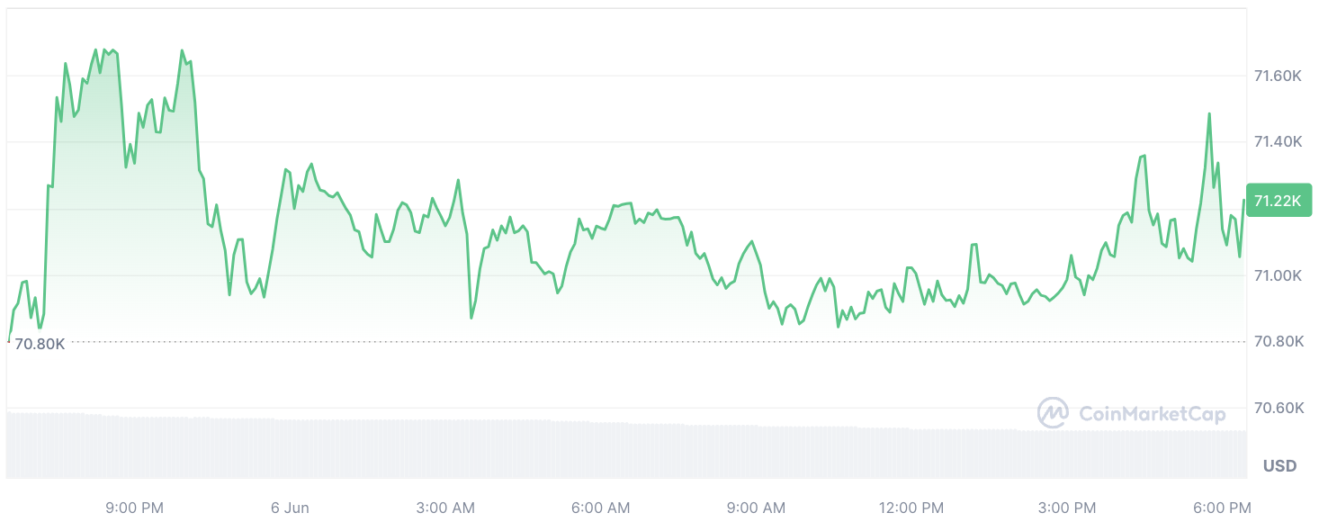

Meanwhile, Bloomberg reported that the short-term 30-day correlation between Bitcoin and the U.S. tech-heavy Nasdaq 100 index is about the highest since early 2023. This suggests that further gains in the stock index could be accompanied by higher gains in the cryptocurrency market leader.

